Mississippi Art Education Association
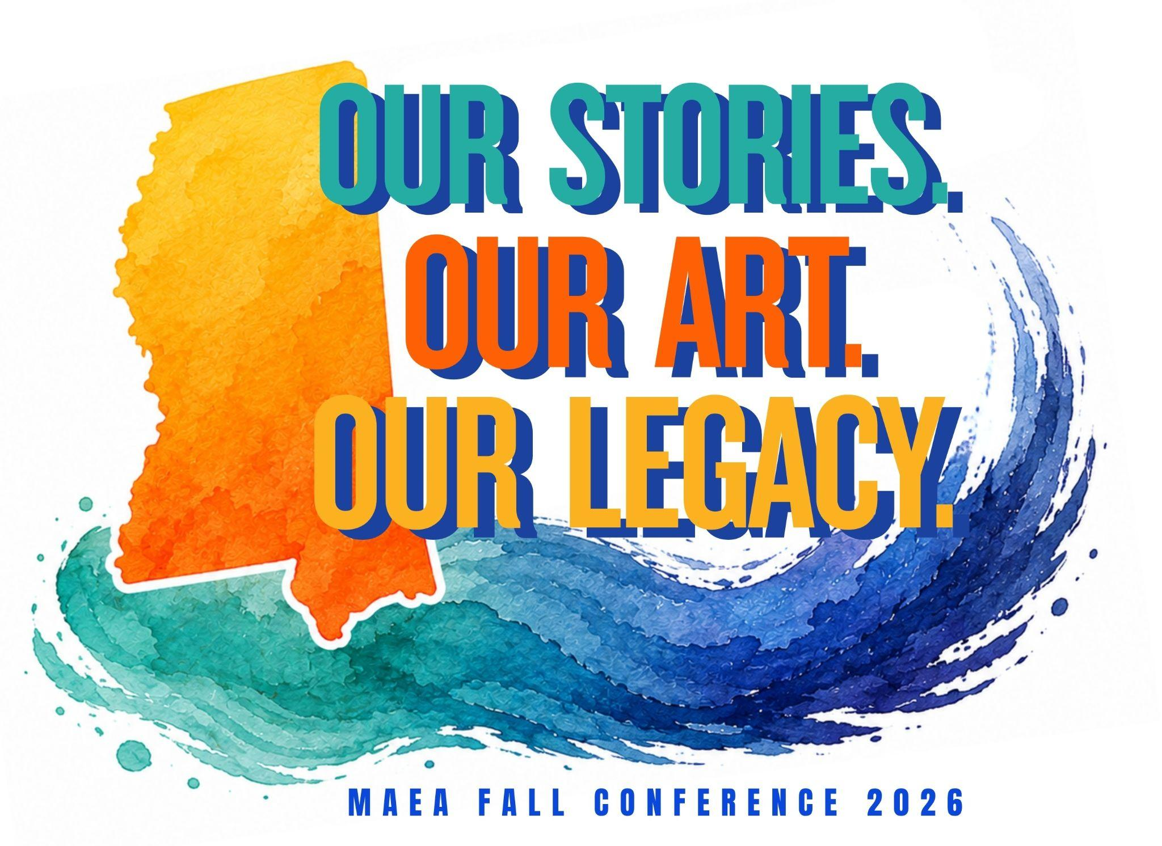
Fall Conference 2026
Our Stories. Our Art. Our Legacy.
October 22-24, 2026

Mississippi Museum of Art
and
Mississippi Christian University Department of Art
Gore Arts Complex
Friday Keynote Speaker: Felandus Thames

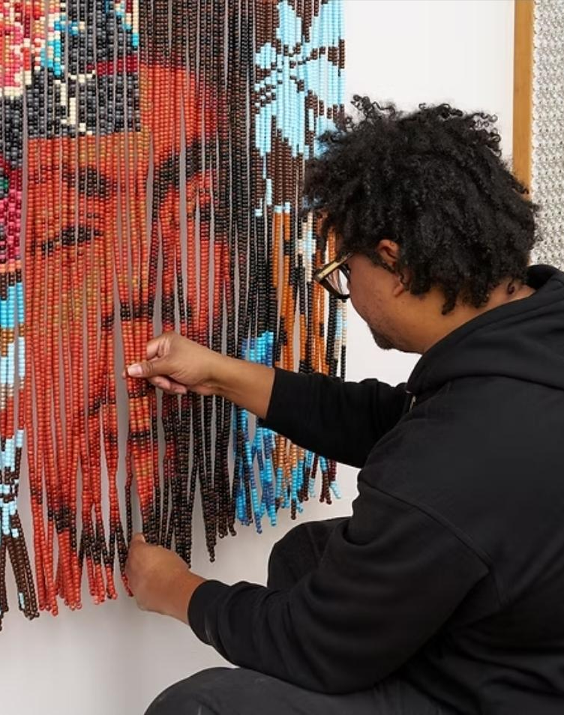
Bio: Felandus Thames is a conceptual artist born in Jackson, Mississippi, whose work explores memory, identity, race, gender, history, and the cultural meaning embedded in everyday objects. Working across painting, sculpture, installation, and found materials, Thames transforms familiar objects into thought-provoking works that invite viewers to reconsider the stories and assumptions attached to them.
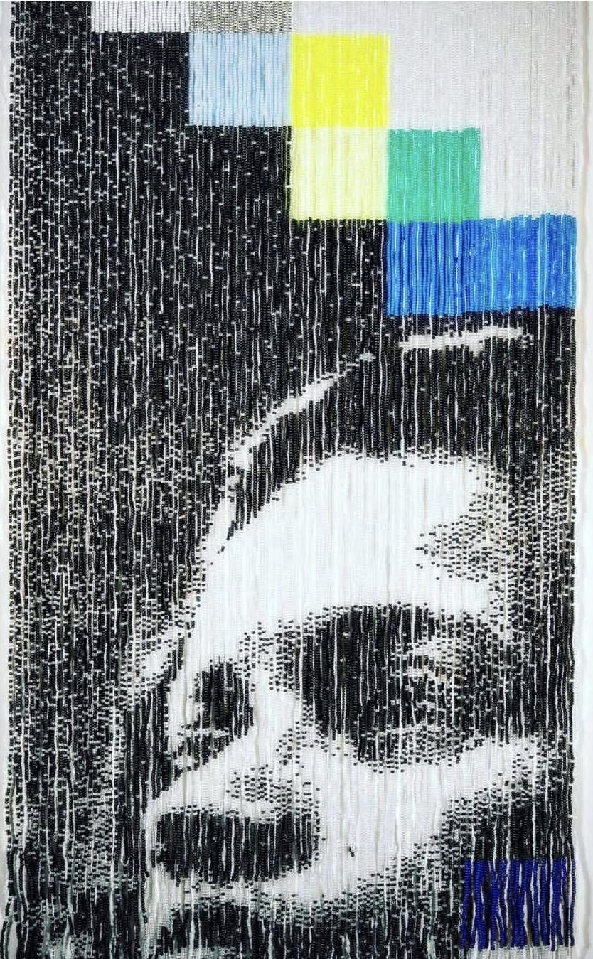
A graduate of Jackson State University, Thames earned his MFA in Painting and Printmaking from the Yale School of Art in 2010. His work has been exhibited nationally and internationally, including at the San Francisco Museum of Modern Art, Cleveland Museum of Art, Mississippi Museum of Art, Virginia Museum of Fine Arts, Contemporary Arts Museum Houston, Crystal Bridges Museum of American Art, and the Museum of African Diaspora. His work was also featured in The Dirty South: Contemporary Art, Material Culture, and the Sonic Impulse, a major traveling exhibition examining the influence of Southern Black culture on contemporary art.
Thames has received recognition from the Harpo Foundation and the Louis Comfort Tiffany Foundation, and his work is held in collections including the Mississippi Museum of Art, Mystic Seaport Museum, Florence Griswold Museum, and The Studio Museum of Harlem. He has also served as an assistant professor at the Rhode Island School of Design.
At the heart of Thames’s practice is an interest in the ways materials can carry memory and history. Rather than simply providing answers, his work often creates questions—encouraging viewers to examine cultural narratives, personal experiences, and the complicated histories that shape the world around us. His ability to combine humor, beauty, discomfort, and social commentary makes his work especially compelling for audiences interested in contemporary art and the power of creative expression. You can learn more about what he’s got to offer over at www.felandus.com
Professional Development in the Studio
Thursday, October 22nd, 2026
Mississippi Museum of Art, Mississippi Christian University & Pearl River Glass Conservatory

This year we are offering five all-day studio concentrations. Each of these sessions will last five hours on Thursday and will cost $75 which includes all supplies. You must register for the conference in order to enroll and attend one of these workshops.

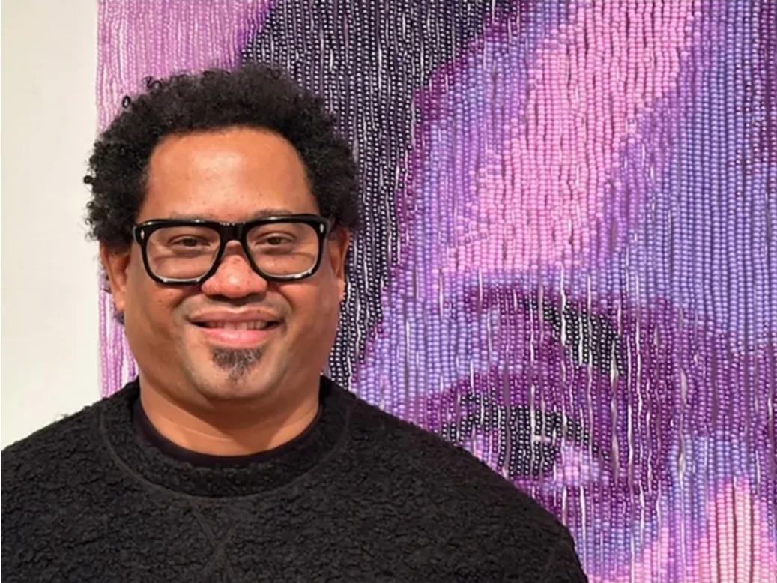
Masterclass with Felandus Thames

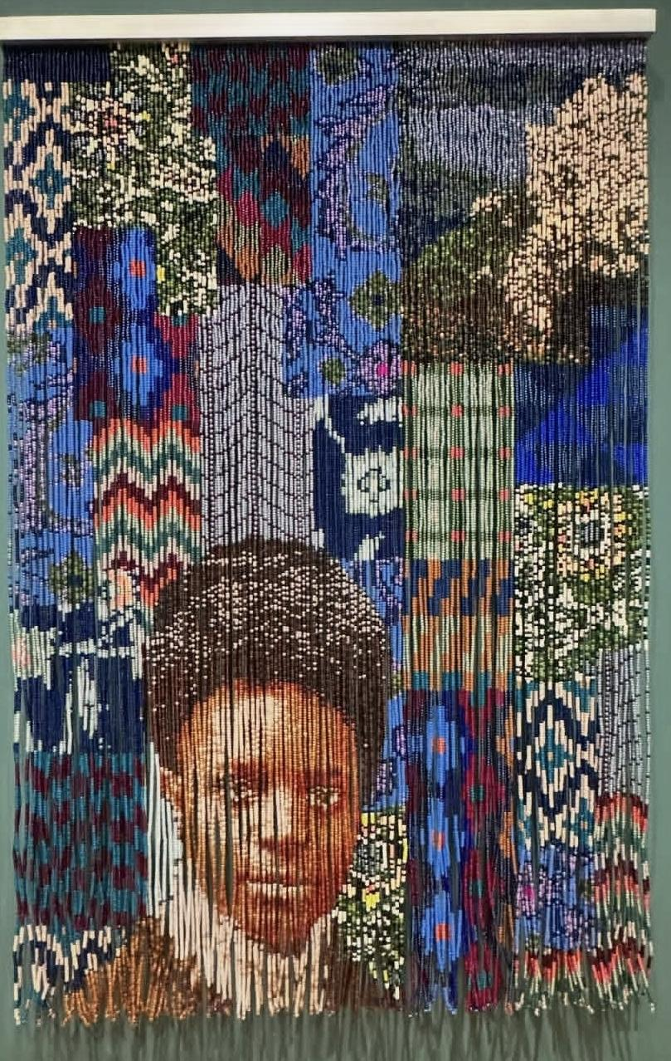
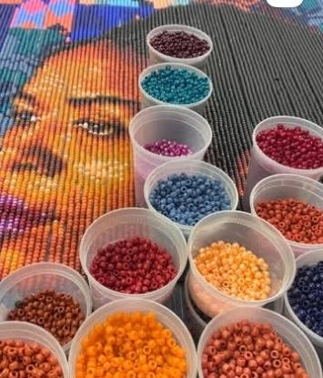
Join acclaimed artist Felandus Thames for an inspiring, hands-on masterclass exploring the power of art, storytelling, and personal perspective. Participants will engage with Thames’s creative process and ideas while experimenting with materials, concepts, and approaches that encourage artists and educators to think beyond traditional boundaries. Come ready to create, reflect, and discover new ways to turn lived experiences into meaningful visual expression.
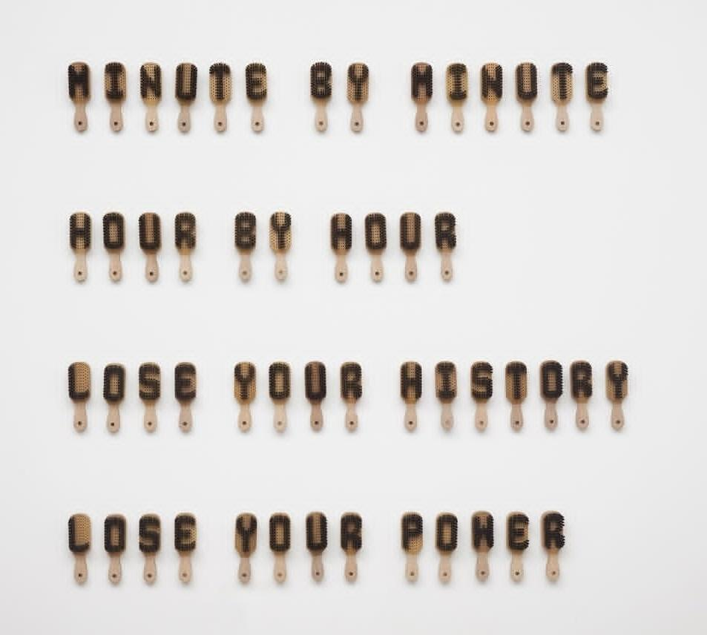
Limit 25 Participants.
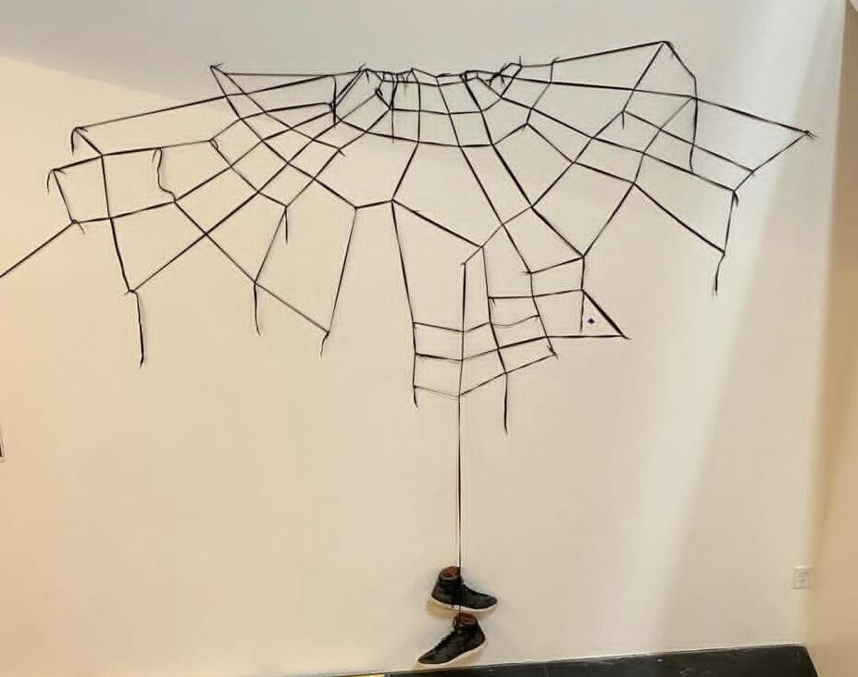

Tabletop Clay Fountain with Lauren Lewis
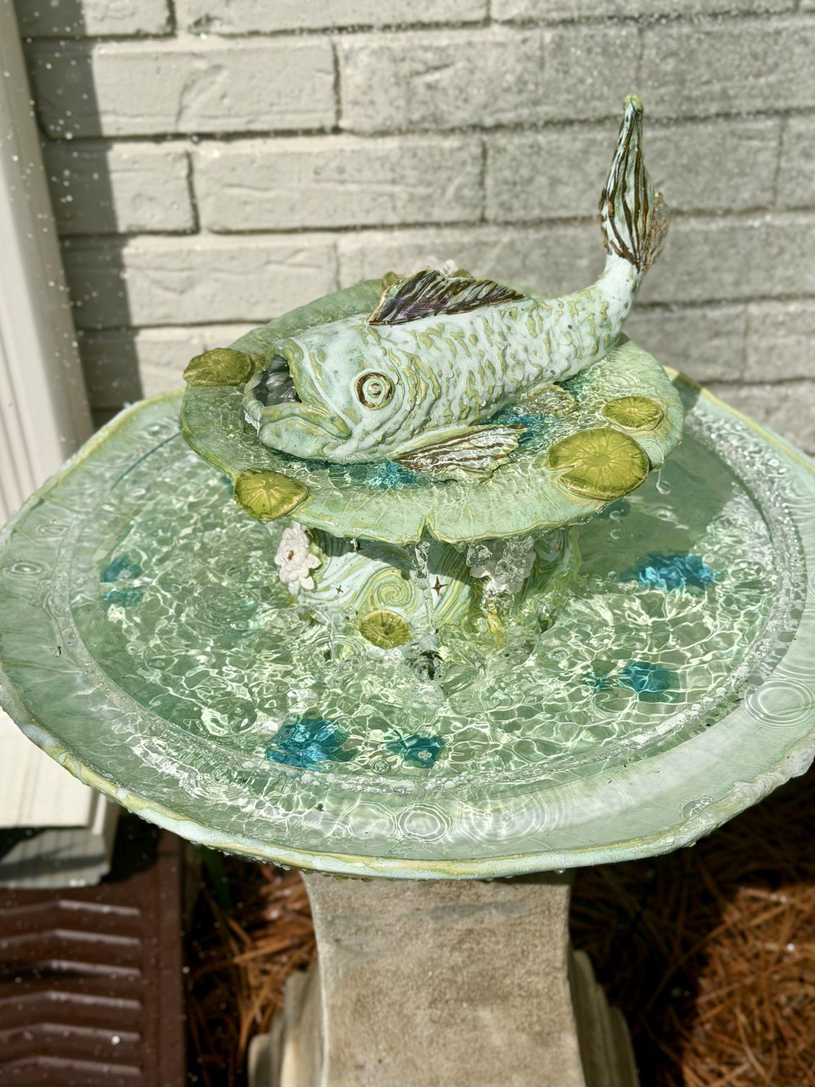
Join full-time ceramic artist Lauren Lewis of La Le Pottery for a hands-on workshop where you’ll create your very own whimsical tabletop clay fountain! Known for her fantasy-inspired pottery, intricate details, and love of creating magical pieces inspired by nature, Lauren brings a playful and bright style to her work.


You’ll be guided through the process of designing and hand-building a small functional fountain, with plenty of room to add your own creative touches, ideas, and personality. No previous pottery experience is necessary, and kiln firing and shipping accommodations can be coordinated as needed. Come ready to get your hands muddy and make something functional, beautiful, and uniquely your own! Limit 10 Participants.

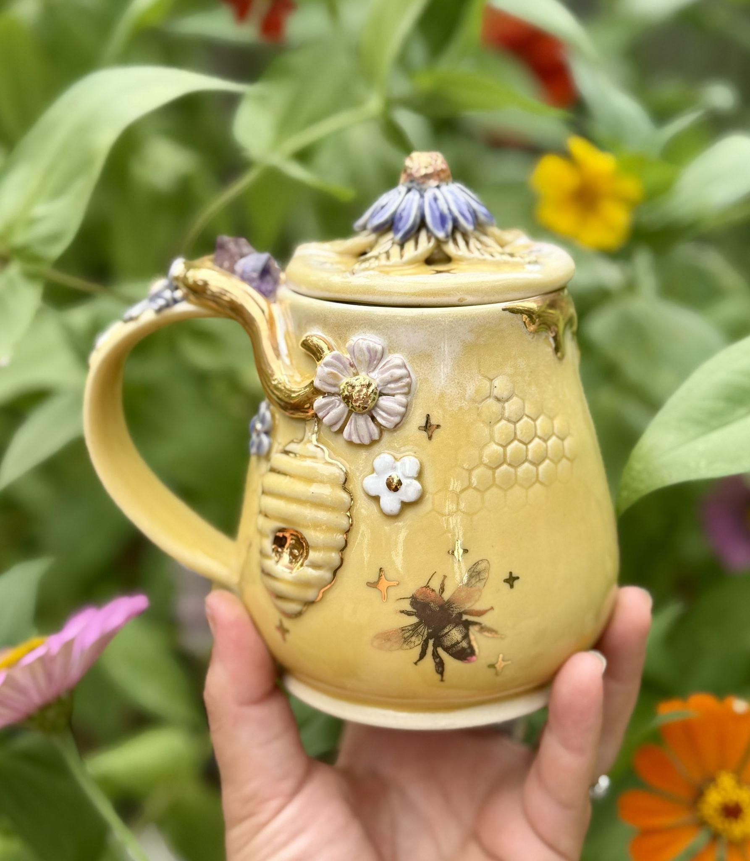

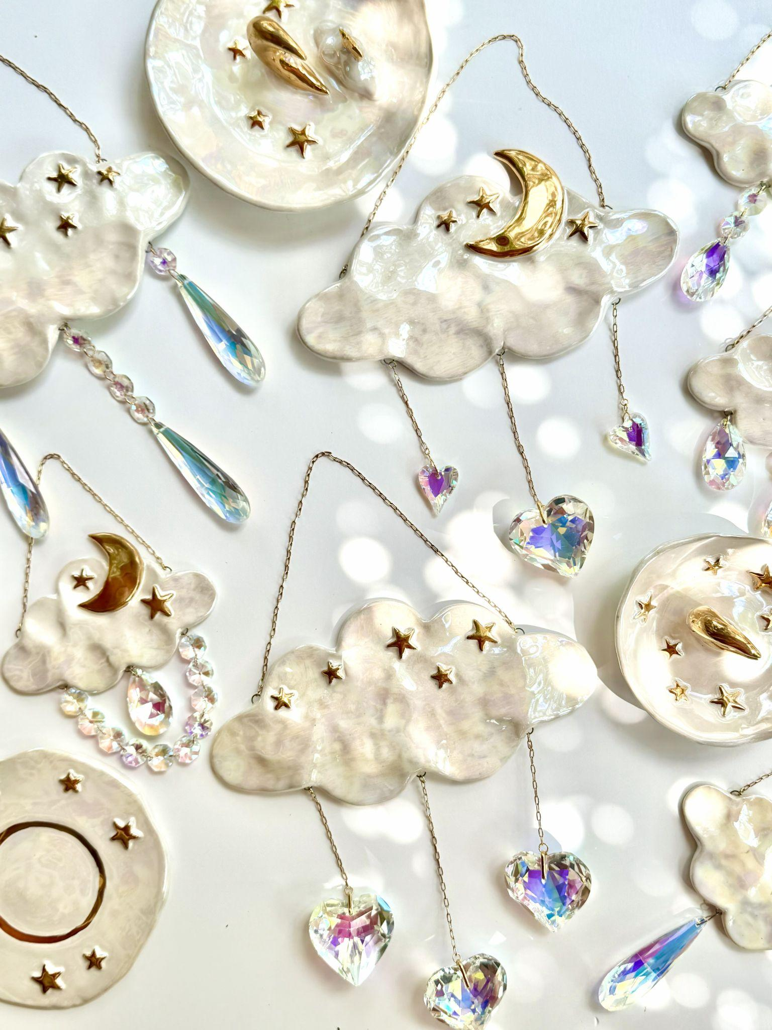
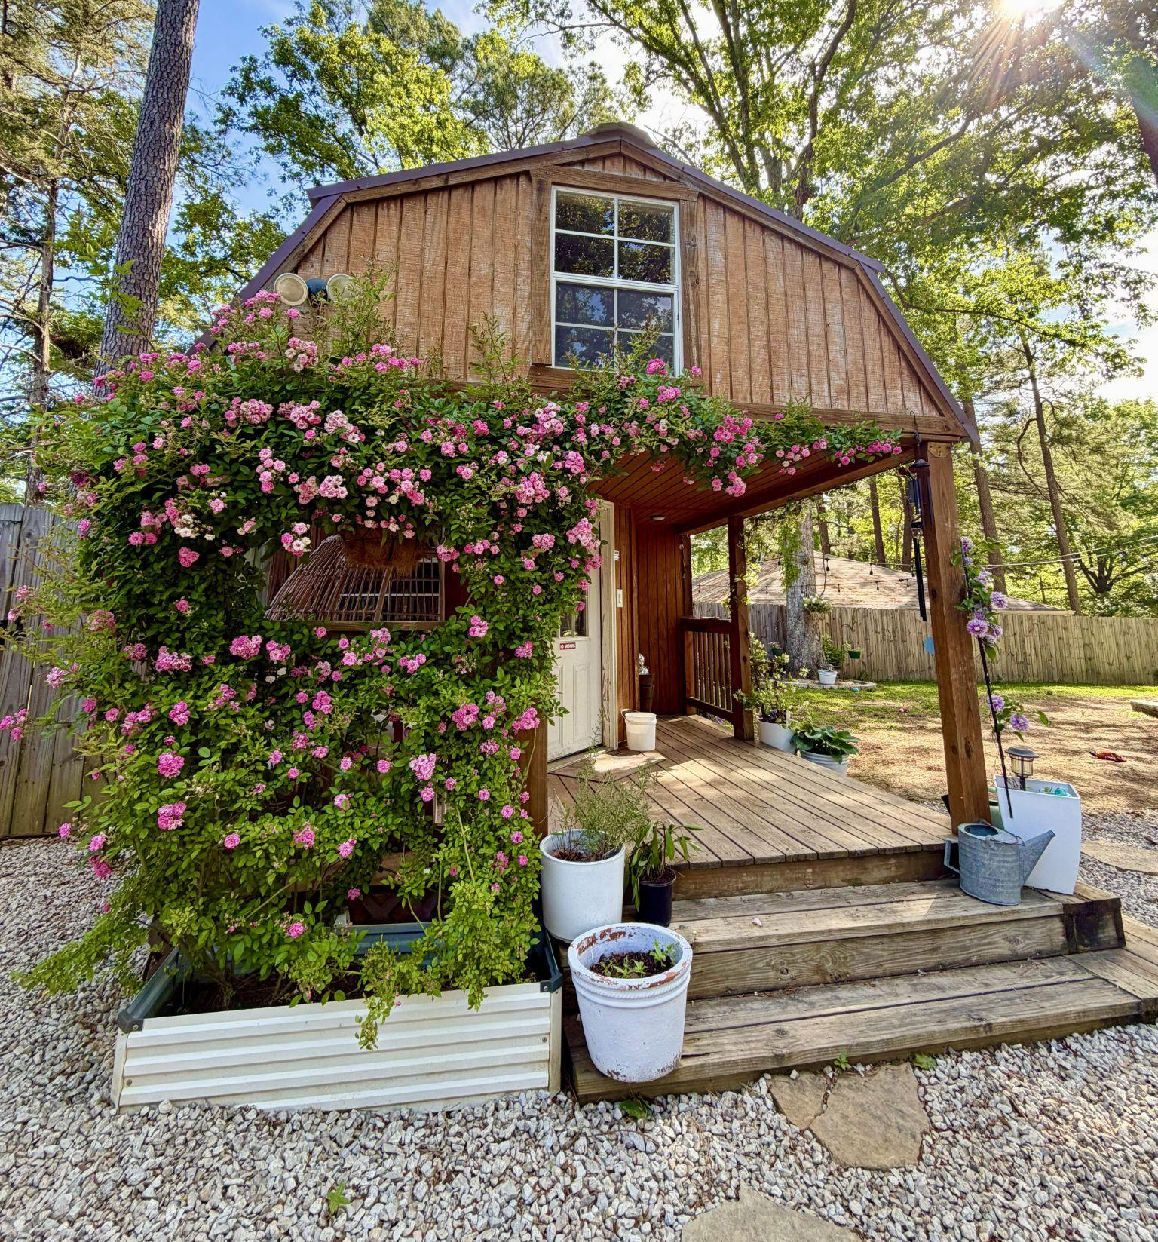

Trashed to trendy: A Recycled Runway Workshop with Felicia Lee and Vashti Graham

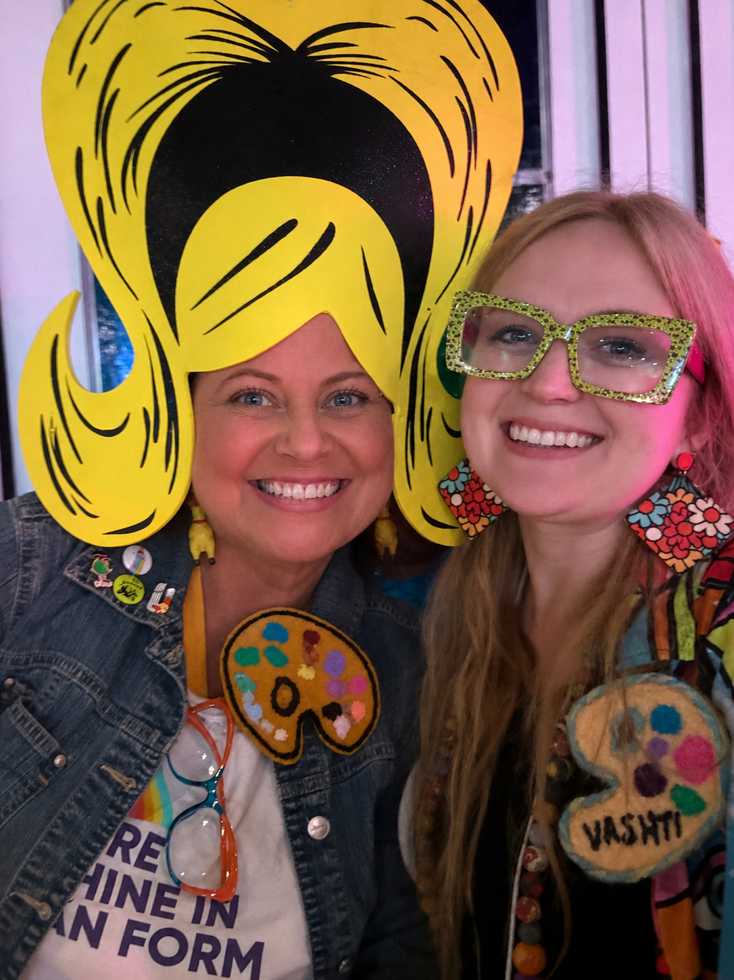
Turn the everyday into something uniquely yours. Join Pearl High School and Pearl Junior High art teachers, Felicia Lee and Vashti Graham, in this hands-on workshop where participants will transform a pair of jeans or another clothing item into a personalized statement piece while exploring a range of creative techniques, using recycled and mixed medium materials. Along the way, you’ll discover additional wearable art and accessories, discover ways to give discarded materials, new life and leave with classroom ready ideas that encourage creativity, sustainability and self expression. Participants will also be able to turn a canvas bag into wearable art. Walk away with new pieces, adaptable lesson ideas, and new inspiration for your classroom. Bring a pair of jeans, a jacket or another item you’d like to repurpose and get ready to turn trash into trendy. Limit 25 participants.

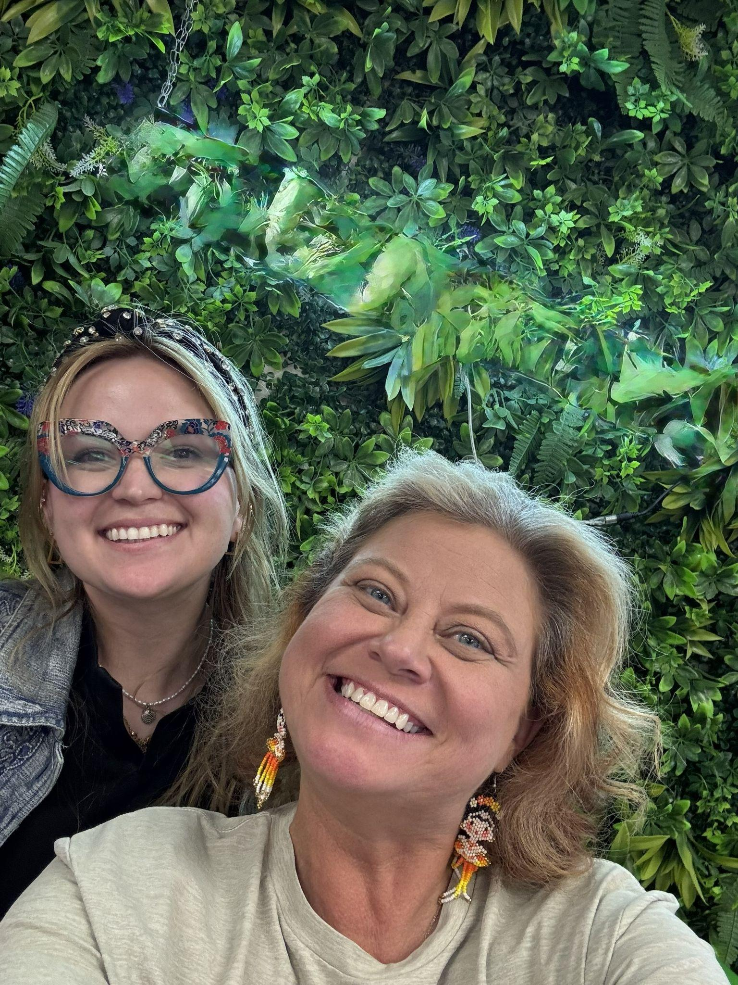

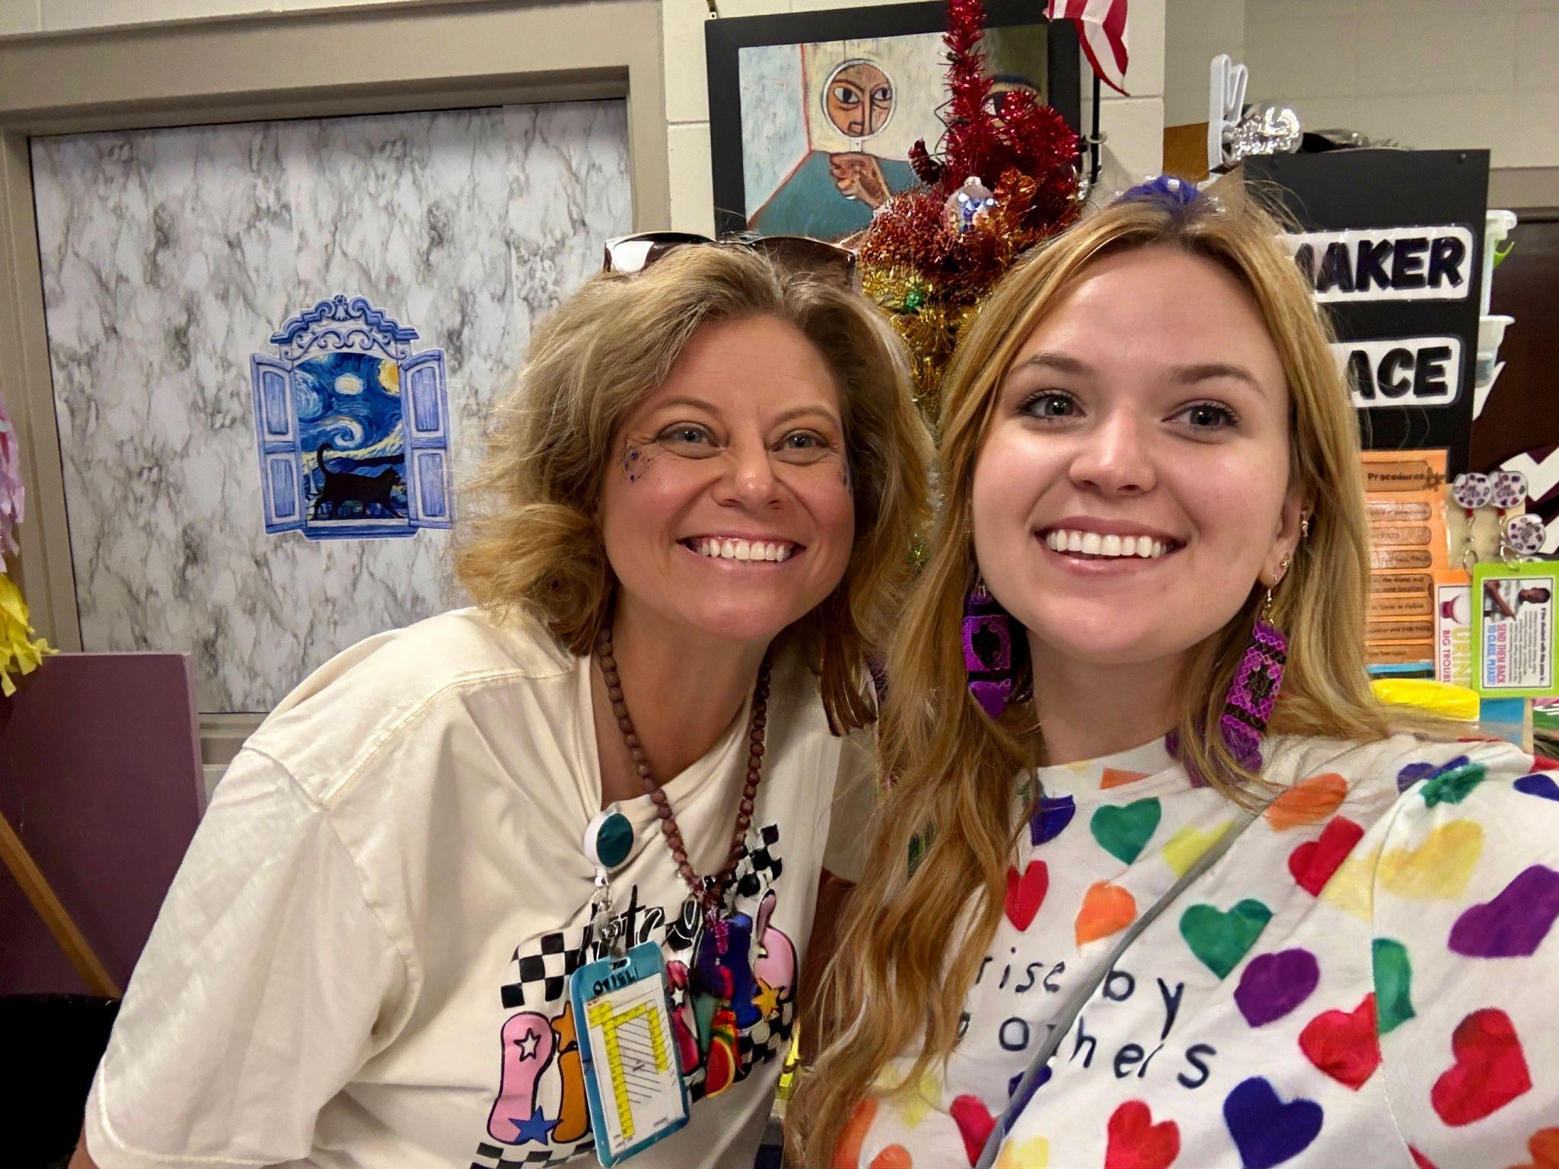

Stone Carving: From Cathedral Flowers to Crucifixes with James Jackson

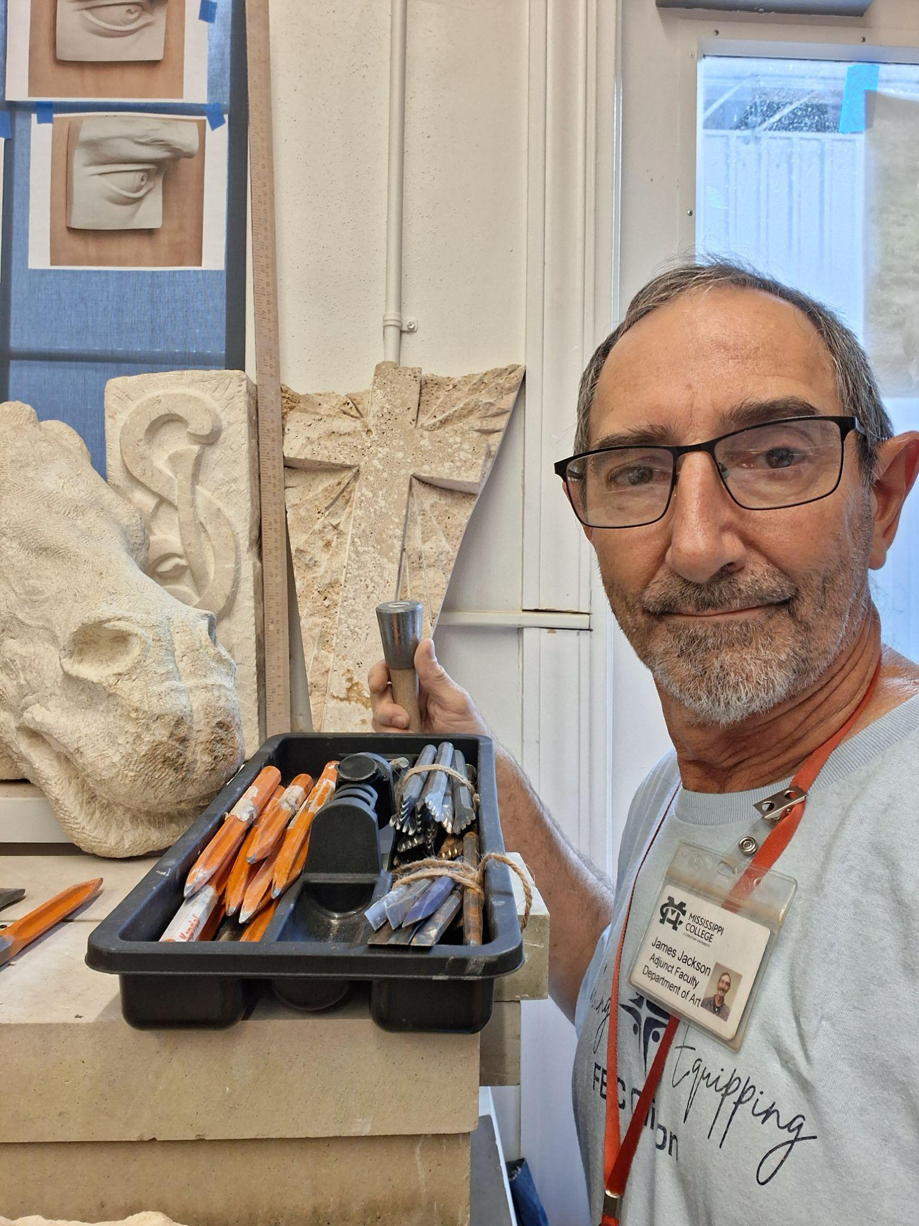
Step into the world of stone carving with artist and MC Adjunct Professor James Jackson. Designed for art educators, this hands-on workshop invites teachers to experience the timeless process of carving stone—from decorative cathedral florets to traditional crucifixes—while exploring techniques inspired by masters like Michelangelo. Come ready to get your hands dirty, experiment with the material, and discover a new sculptural process to bring back to your classroom. Workshop will take place at Mississippi Christian University's Gore Art Center in Clinton, MS.
Limit 10 Participants.
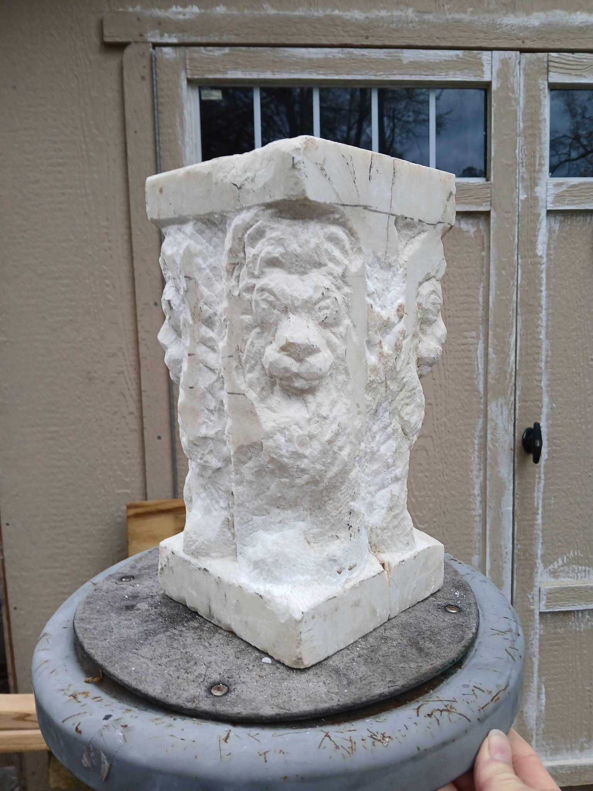
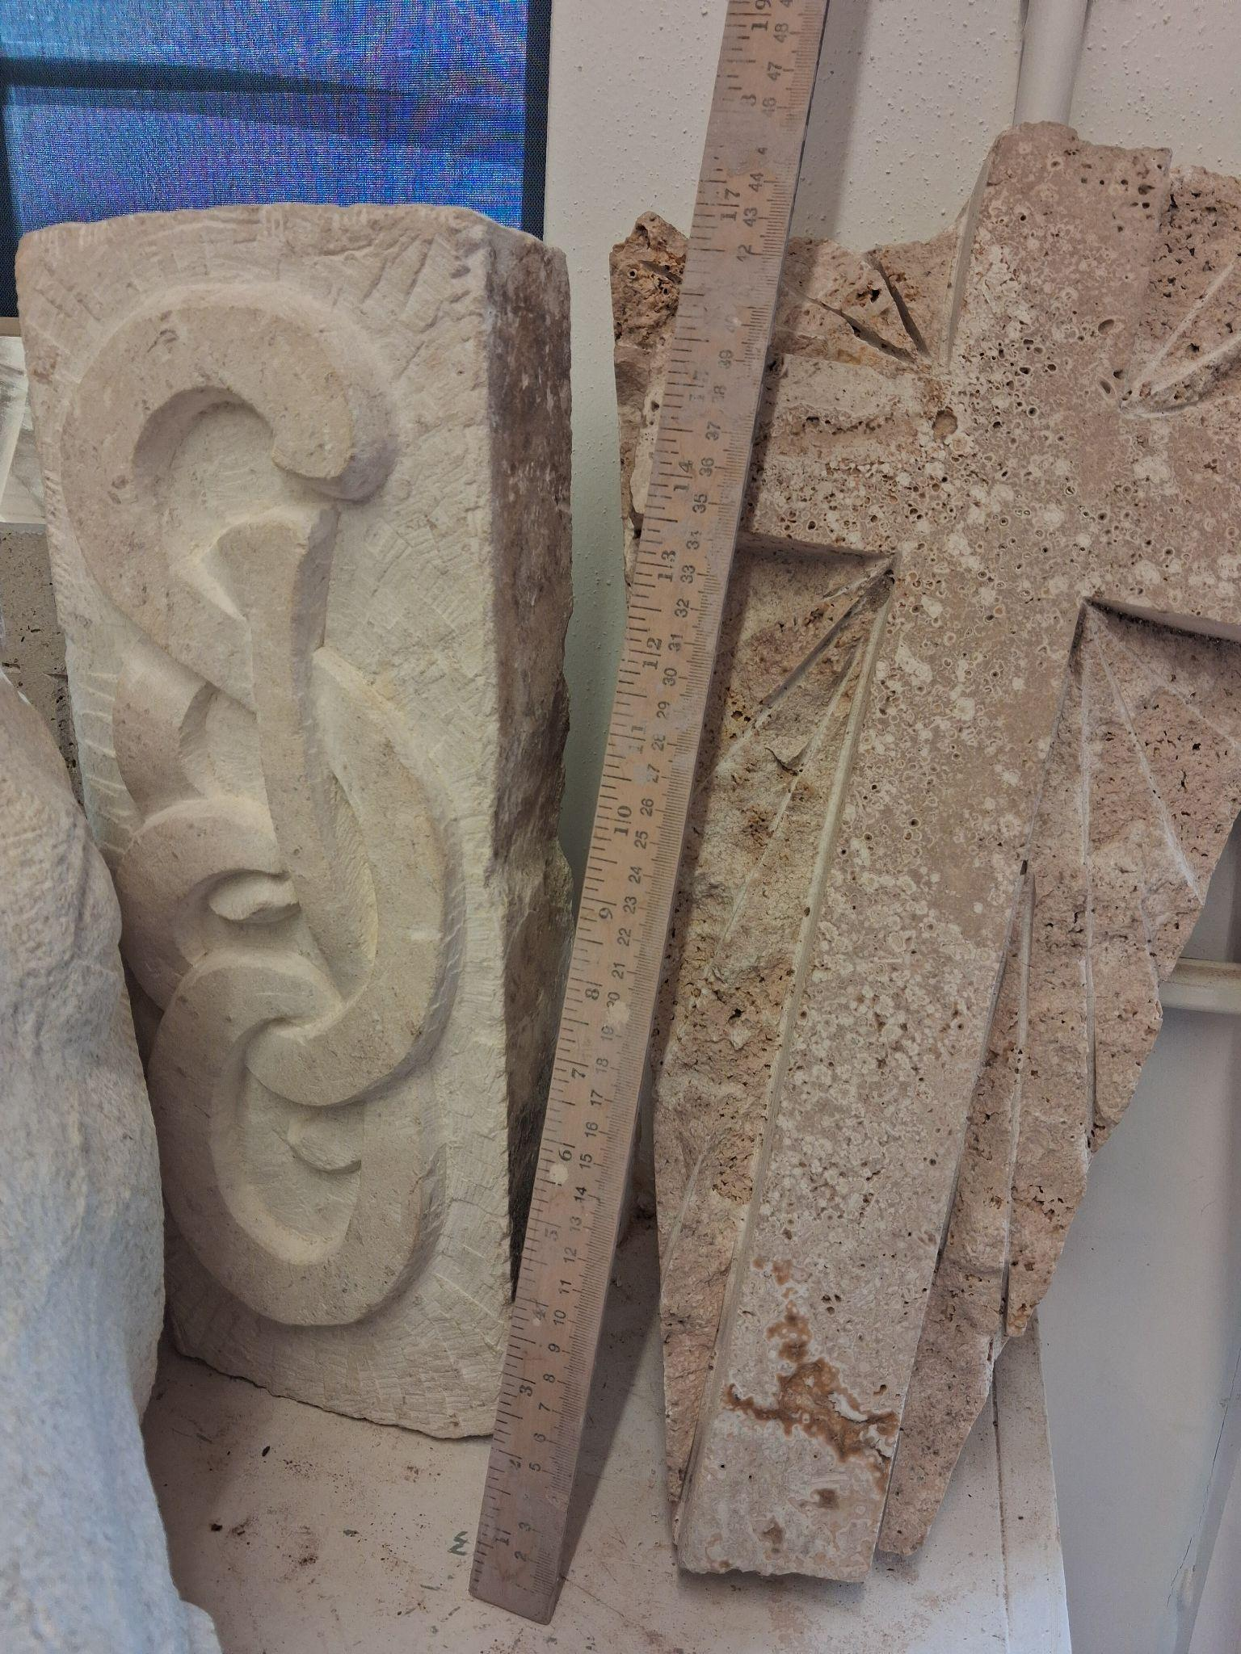

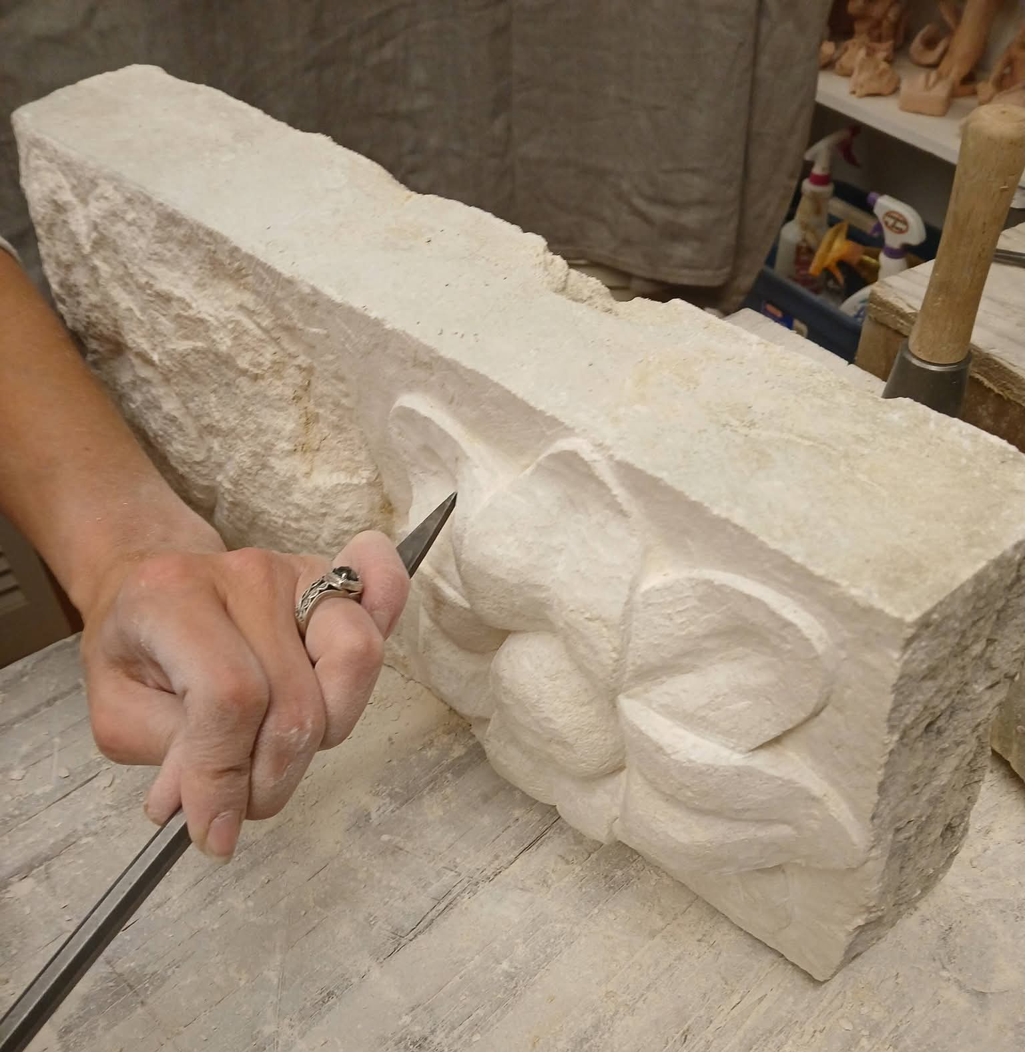
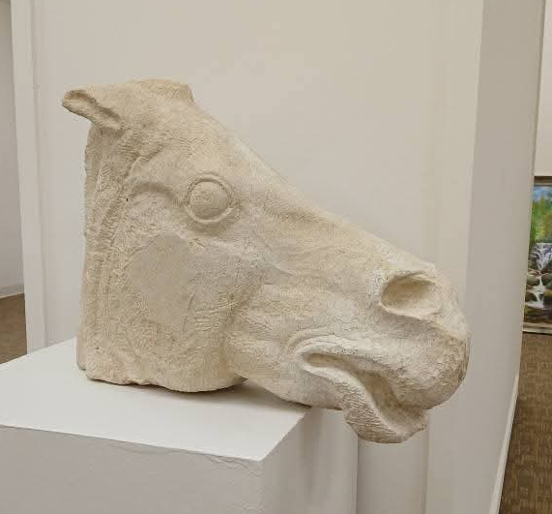

Fused Glass with Pearl River Glass Conservatory

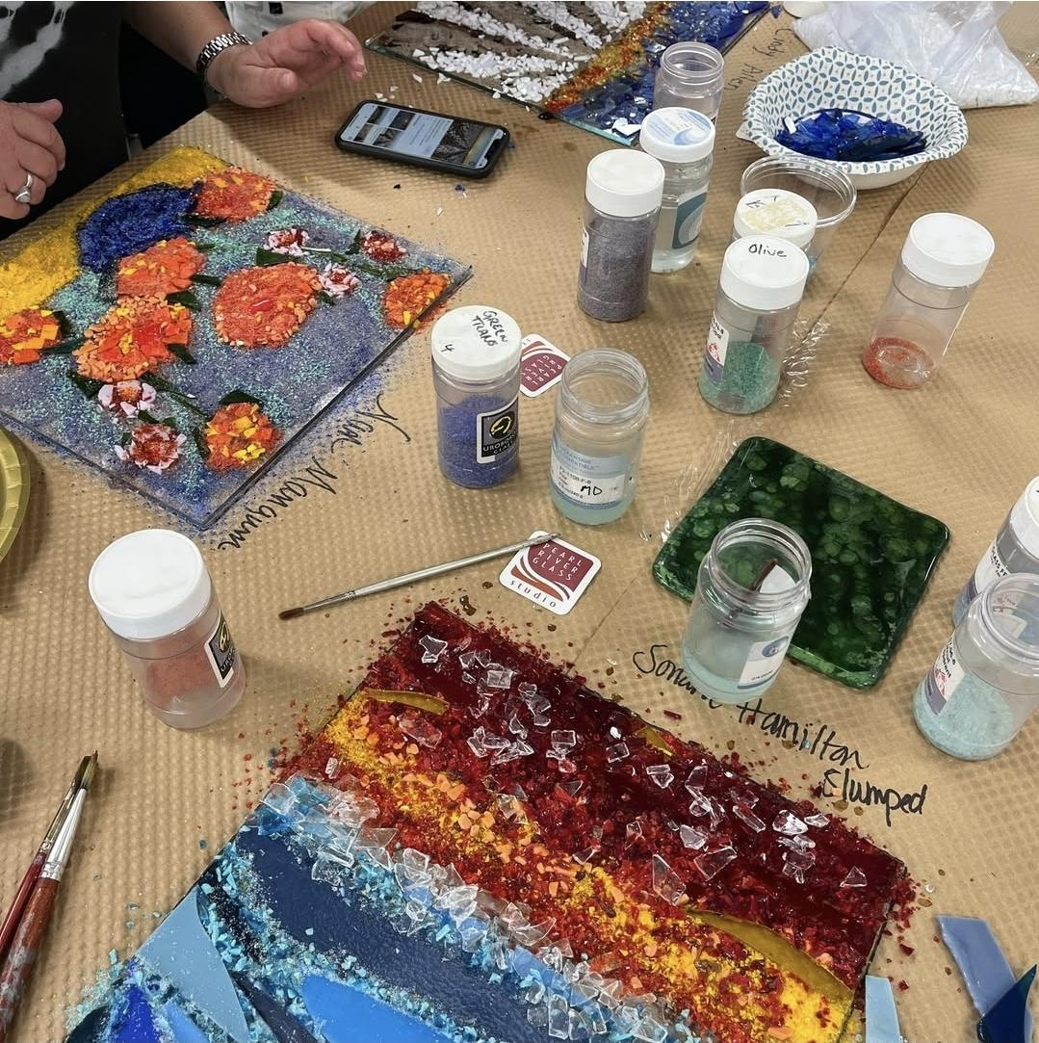
Back by popular demand, Pearl River Glass Conservatory will offer a concentration in their conservatory studios in Midtown Jackson. Participants will learn about fused glass, gain skills to cut and assemble glass, and create multiple items, such as hanging suncatchers and ornaments to keep. Workshop will take place at Pearl River Glass studios.
Limit 24 participants.
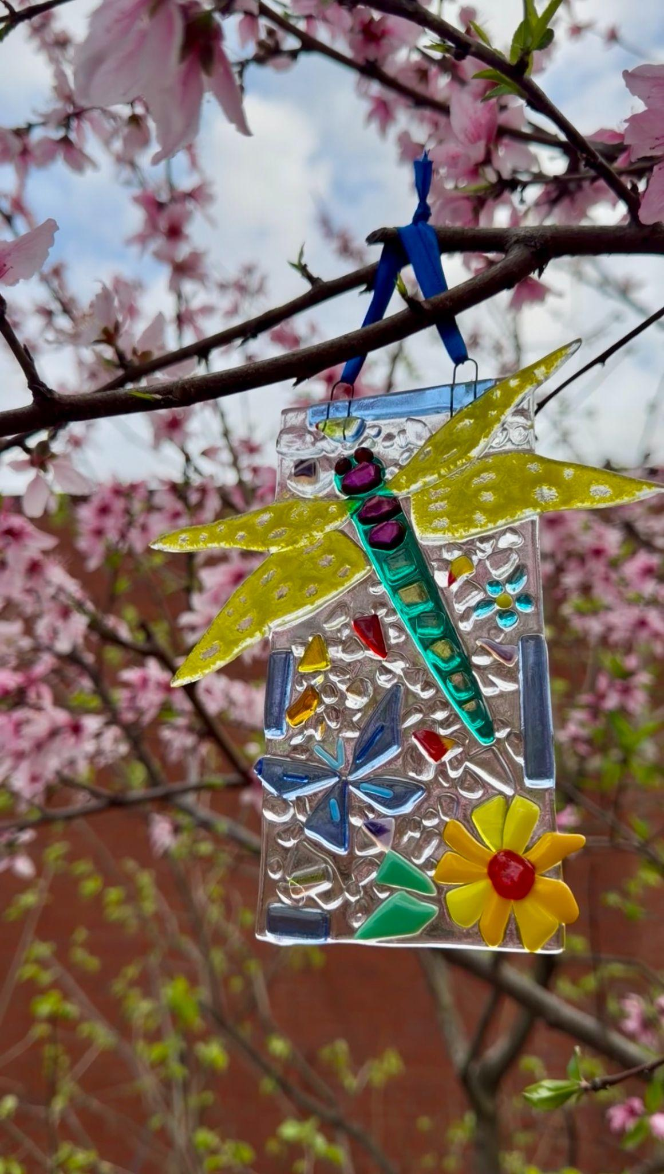
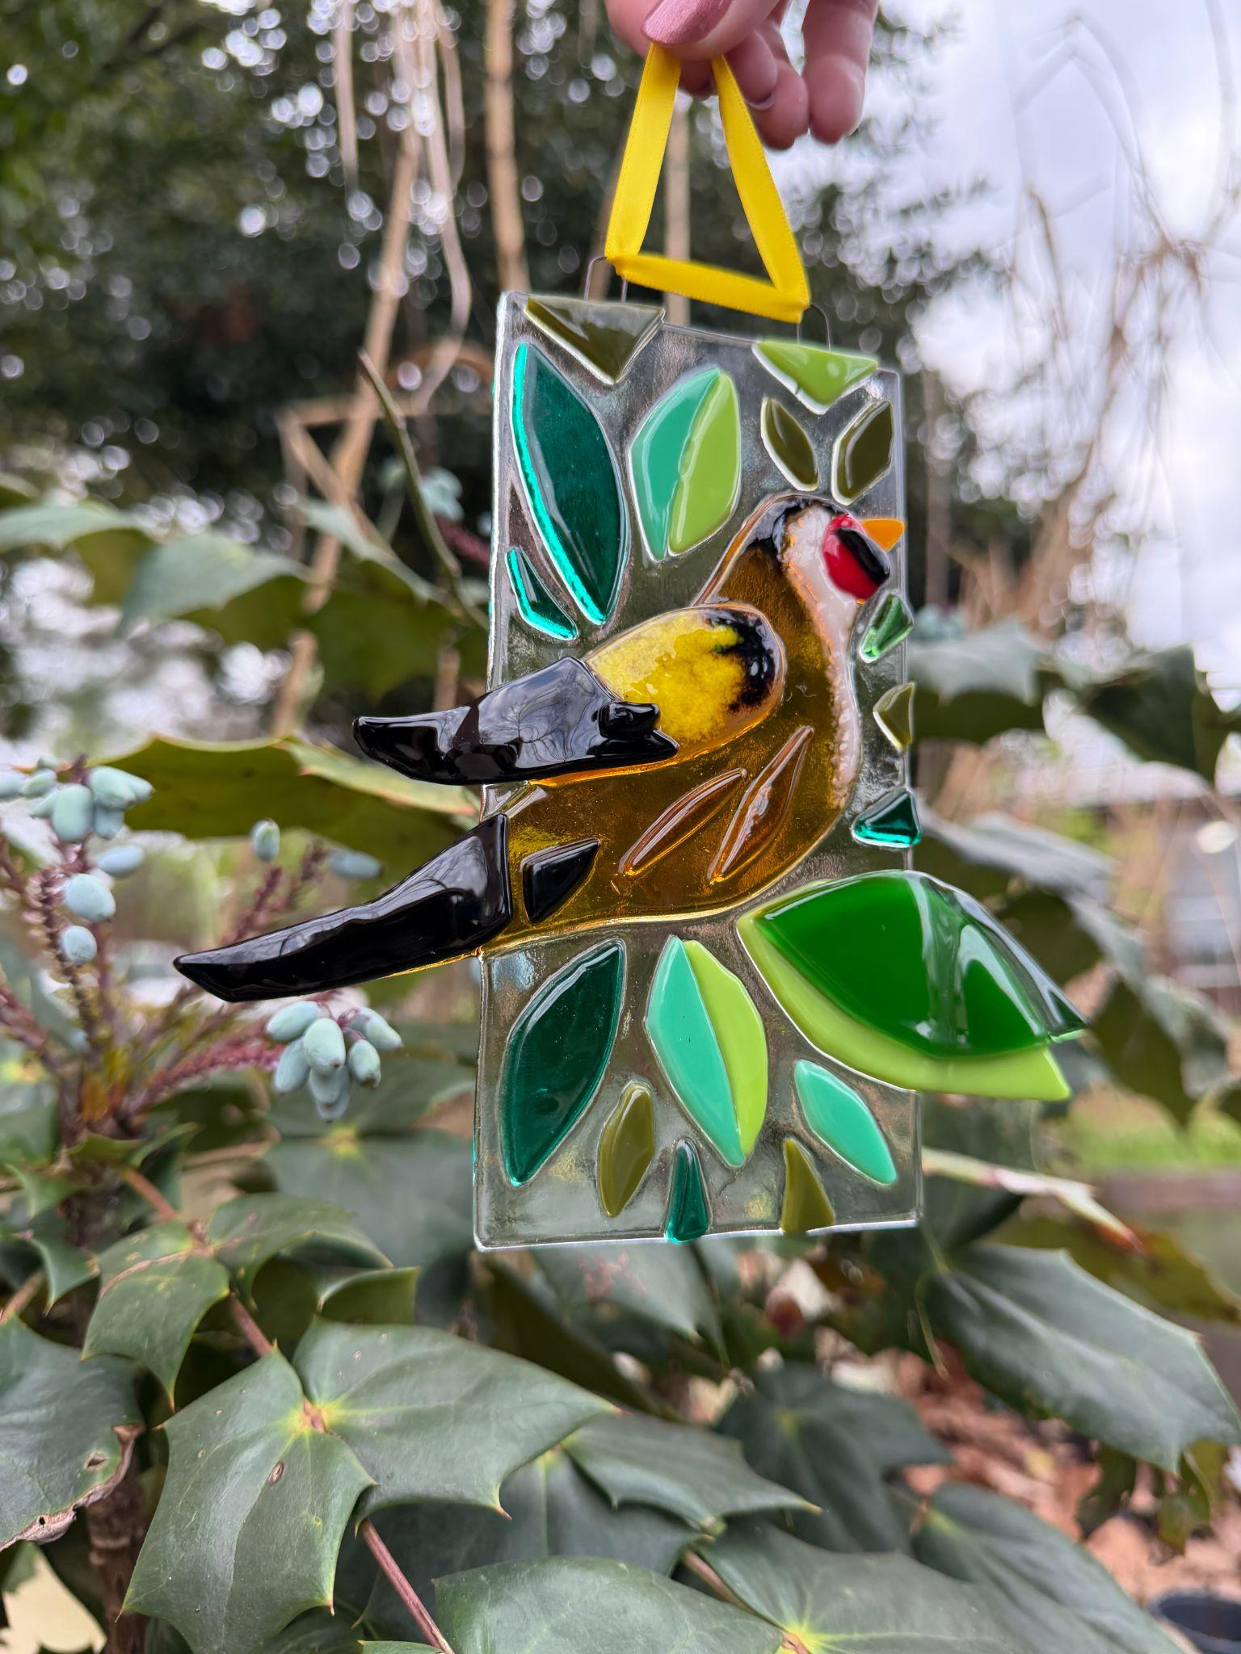

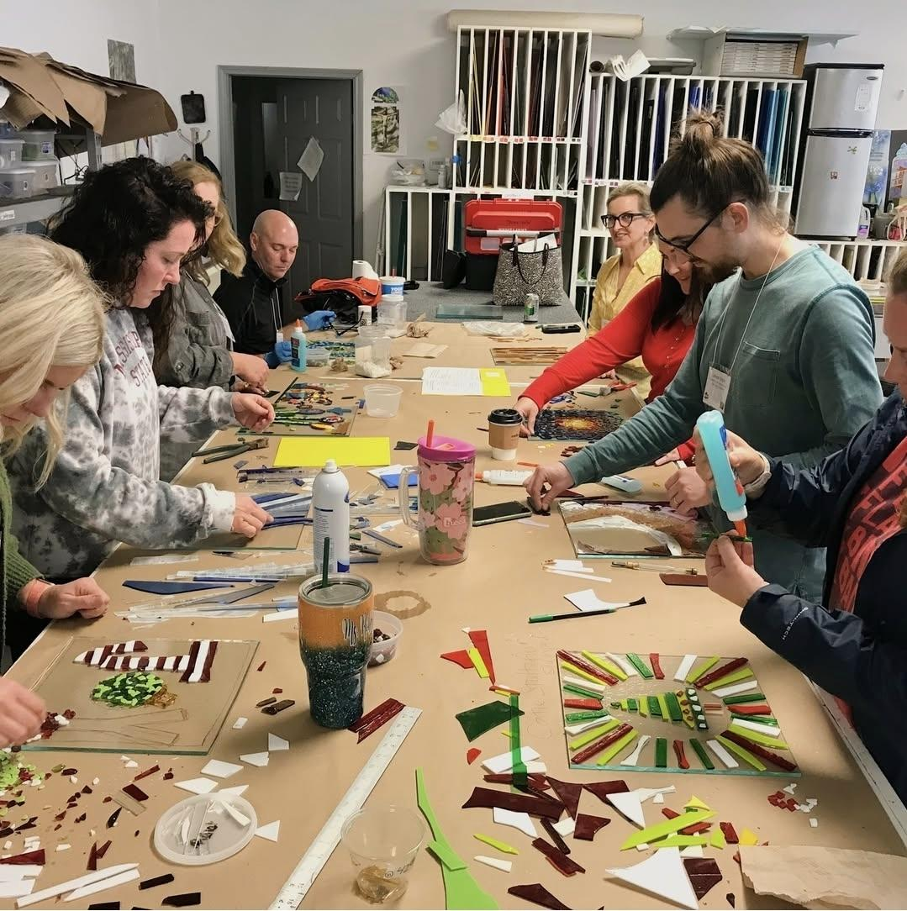

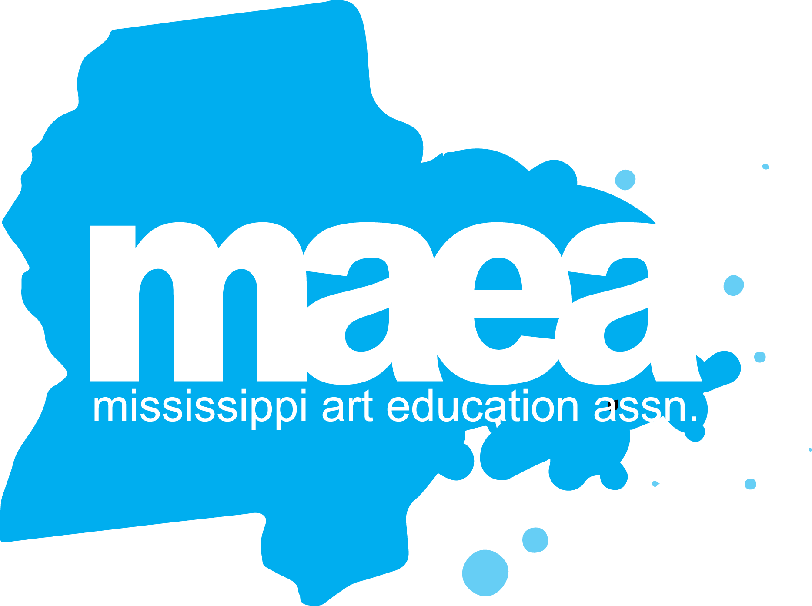

Registration Information
MAEA Fall Conference fees include Friday and Saturday sessions, art supplies needed for the sessions, conference t-shirt or tote bag, coffee and muffins Friday morning, dinner Friday evening at the awards event, and lunch on Saturday. The Thursday studio master classes professional development workshops are an additional $75 which includes needed art supplies available for use.

All sessions are specifically geared to help Visual Arts teachers strengthen their teaching practices and show connections to the Mississippi Visual Arts Standards as well as give teachers opportunities to reflect, problem solve, and share new ideas and experiences. Up to 2 CEUs or 20 contact hours are available during this professional development conference.

Conference Ticket Prices:
- Active Member: $155
- Retired Member: $135
- Student Member: $95
- Non-Member: $195
- Late Registration: $20 added after October 15
- Thursday Studio Master Artist PD Workshops: $75

Regular registration ends October 5th. All registration fees must be paid before session choices can be made. You can receive a full (minus processing fees) refund until October 10th. No refunds beginning October 11th when t-shirts, supplies, and food are ordered. Register early to ensure a spot in the Thursday Studio Art Concentration of your choice. Registration links will be emailed and posted on the MAEA Facebook page and website when available.

Attendees get a choice of a t-shirt or a tote bag with registration.
Conference Schedule

Thursday, October 22, 2026
Mississippi Museum of Art, Pearl River Glass Conservatory, & Mississippi Christian University Gore Arts Center
Time | Event | Location
9:00-9:30 | Registration  Turn in 3X5 Artwork | MMA & PRGC
9:30 – 11:30 | Keynote Masterclass Workshop  Clay Tabletop Fountain Workshop  Recycled Runway Workshop  Stone Carving Workshop  Fused Glass Workshop | MMA & PRGC  MCU GAC
11:30-1:00 | Lunch On Your Own | Jackson restaurants
1:00- 4:00 | Keynote Masterclass Workshop  Clay Tabletop Fountain Workshop  Recycled Runway Workshop  Stone Carving Workshop  Fused Glass Workshop | MMA & PRGC  MCU GAC
4:30-5:30 | MAEA Board of Directors and Officers Meeting | TBD
6:00 | Division Dinners | Jackson restaurants
Friday, October 23, 2026
Mississippi Museum of Art
7:15-8:00 | Registration and Welcome Reception with coffee and breakfast sweets  Turn in 3X5 Artwork | MMA
8:00-8:30 | MAEA Fall Conference Overview  MMA Opportunities-Merry Barnes  Info from MMA gift shop  Door Prizes | MMA
8:45-9:45 | Morning Session | MMA
10:00-11:00 | Friday Keynote Speaker - Felandus Thames  Door Prizes | MMA
11:00-12:15 | Lunch on your own | Jackson  restaurants
12:15-4:30 | Afternoon Sessions | MMA

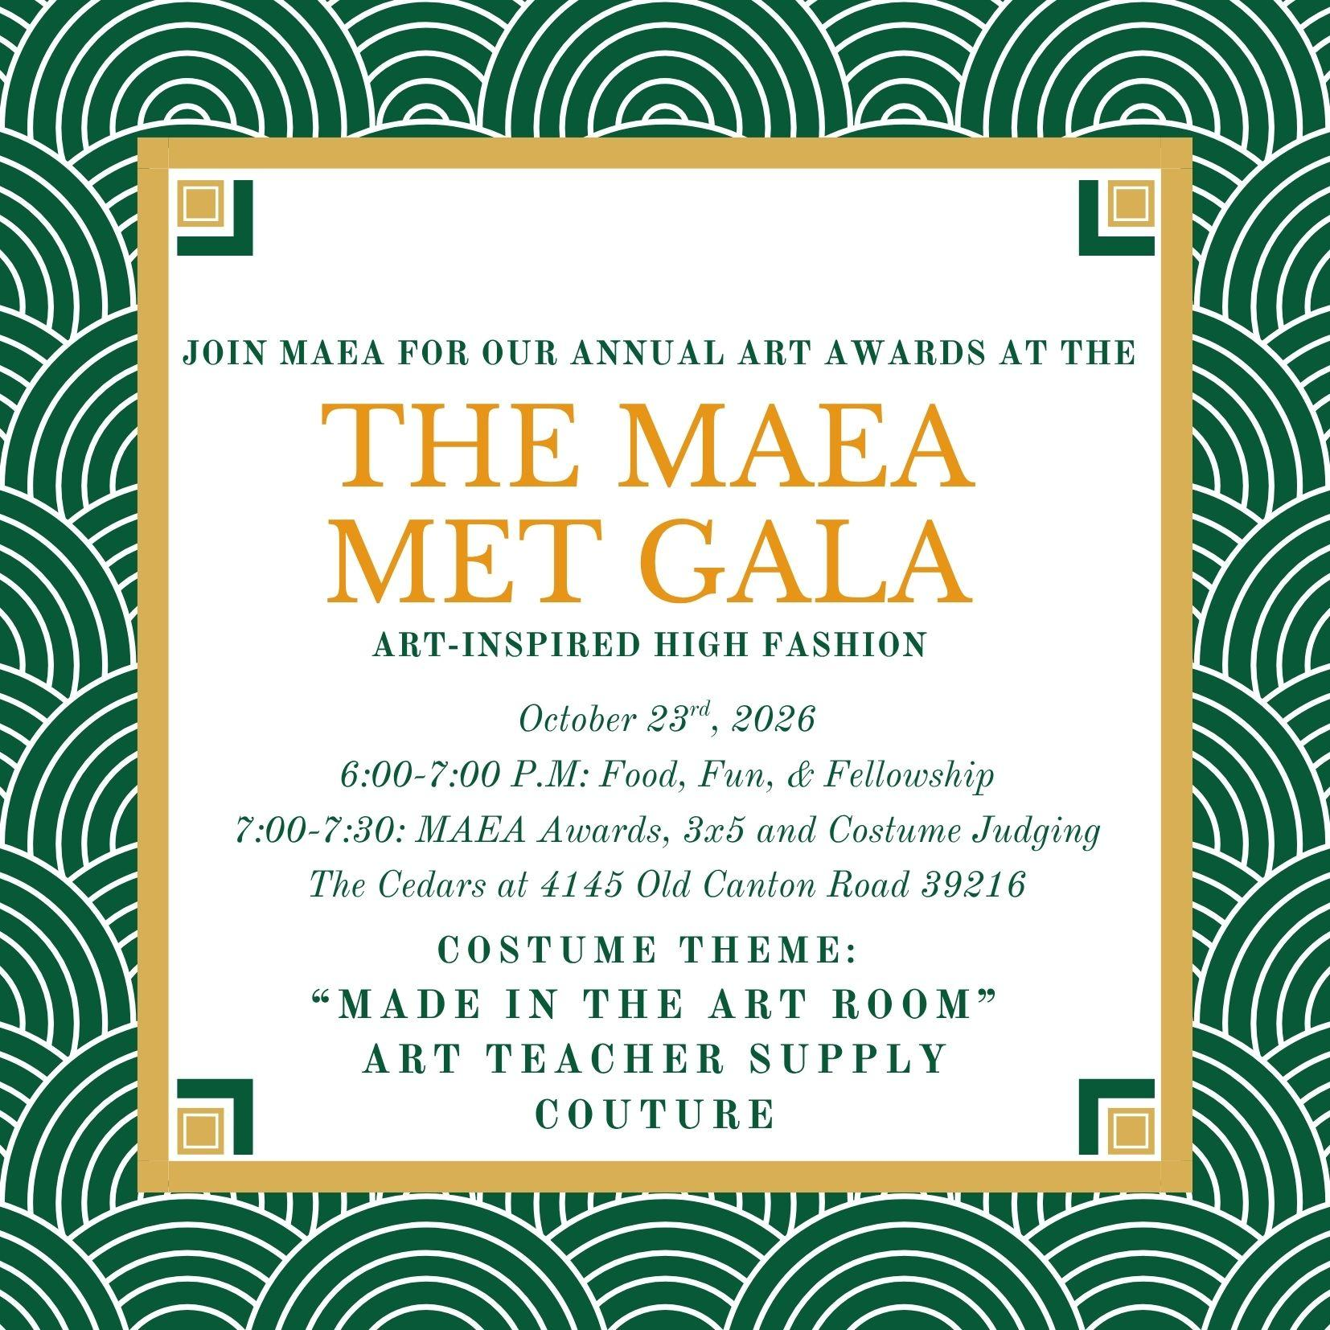

Dinner & Awards Ceremony
Friday Evening, October 23rd, 2026
The Cedars
6:00-8:00 pm | Doors Open at 6:00  5:45 pm Award Recipients Photos  6:00-7:00 pm  Food, Fun, & Fellowship  Art Activities  Costume Contest  7:00 pm MAEA Awards  7:30 pm 3 X 5 Exhibition and Judging  (Cost Included in Conference Registration ) | The Cedars  4145 Old Canton Road,  Jackson, MS 39216

Saturday, October 24, 2026
Mississippi Christian University's Gore Arts Complex

Time | Event | Location
7:30-8:00 | Registration | Mississippi Christian University  Gore Arts Complex (GAC)
8:00-11:00 | Morning Studio Sessions | MC GAC
11:00-11:30 | Look and Learn: Visit Gallery Spaces | MC GAC/Gore Gallery
11:30-12:20 | Lunch and Learn Opportunities:  (lunch included in conference registration) | MC GAC
12:35-1:00 | General Session  Reports from Officers  Information from MC Art Department  Door Prizes | MC GAC: Entergy Theater
1:05- 5:00 | Afternoon Studio Sessions | MC GAC

Friday and Saturday Session choices will become available October 1st. You must be fully paid to be able to pick your sessions.

Teacher Art Show 3 X 5 Exhibition

This year’s 3” X 5” exhibition must fit the size requirements, but can be any subject matter or media.

A cash prize for the Juror’s choice and People’s choice awards will be presented Saturday. Members must pick up their work before they leave on Saturday.

People’s Choice Juror’s Choice Honorable Mention People’s Choice Honorable Mention
Madison Moore Catherine Koehler Jaime Coon
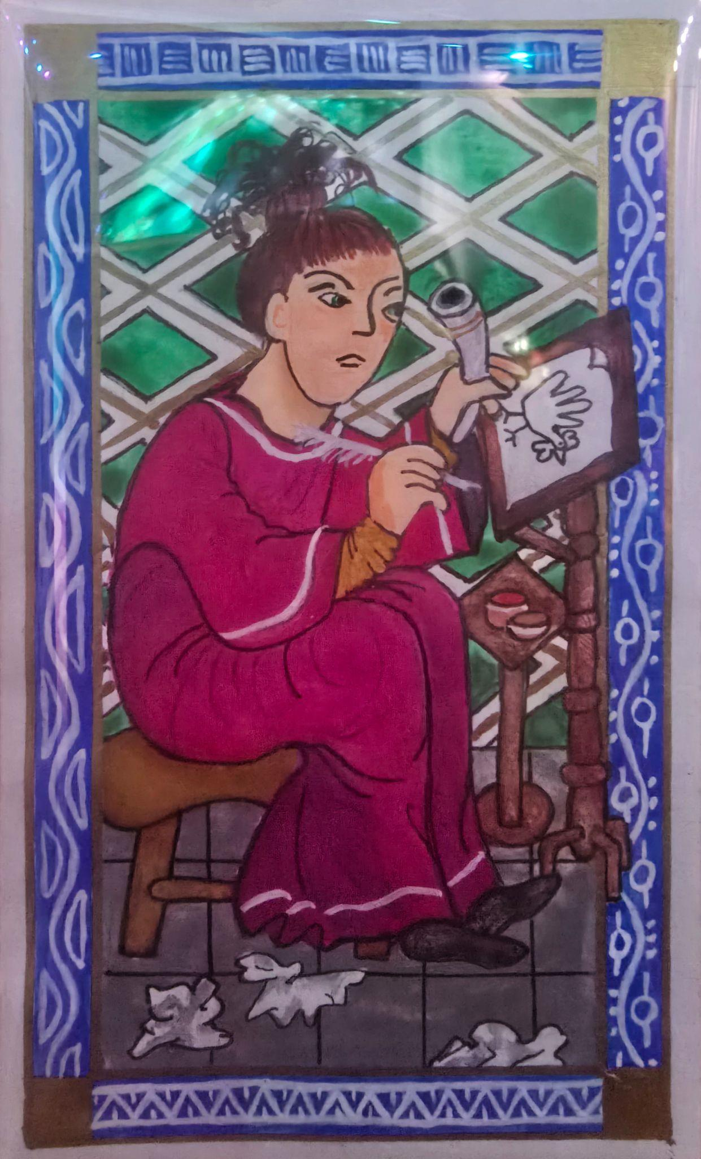
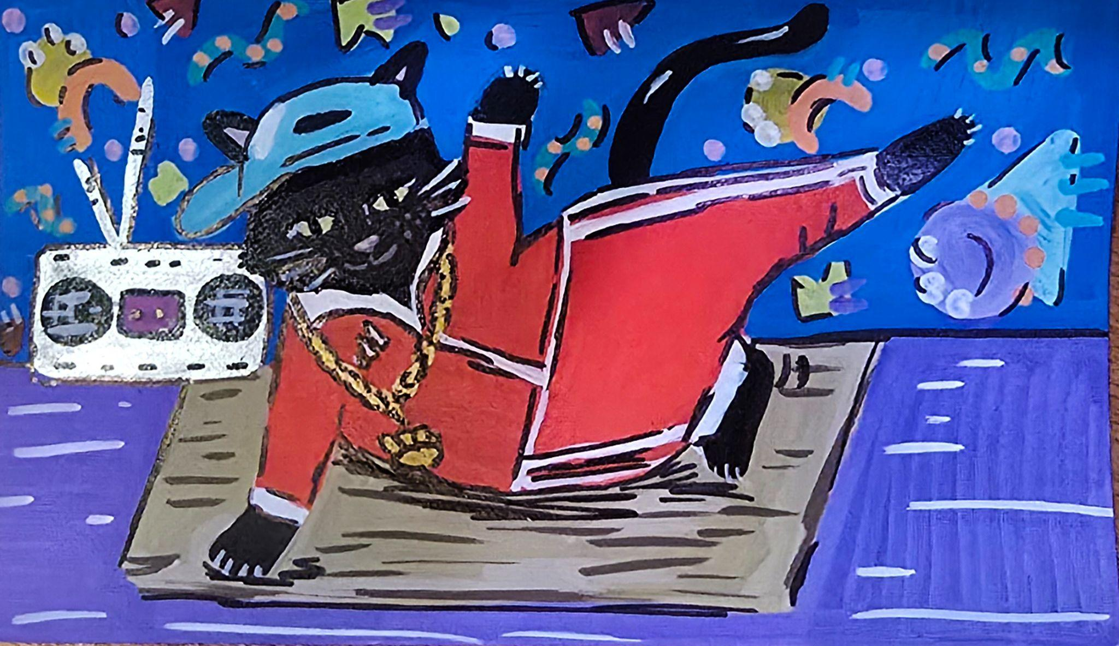
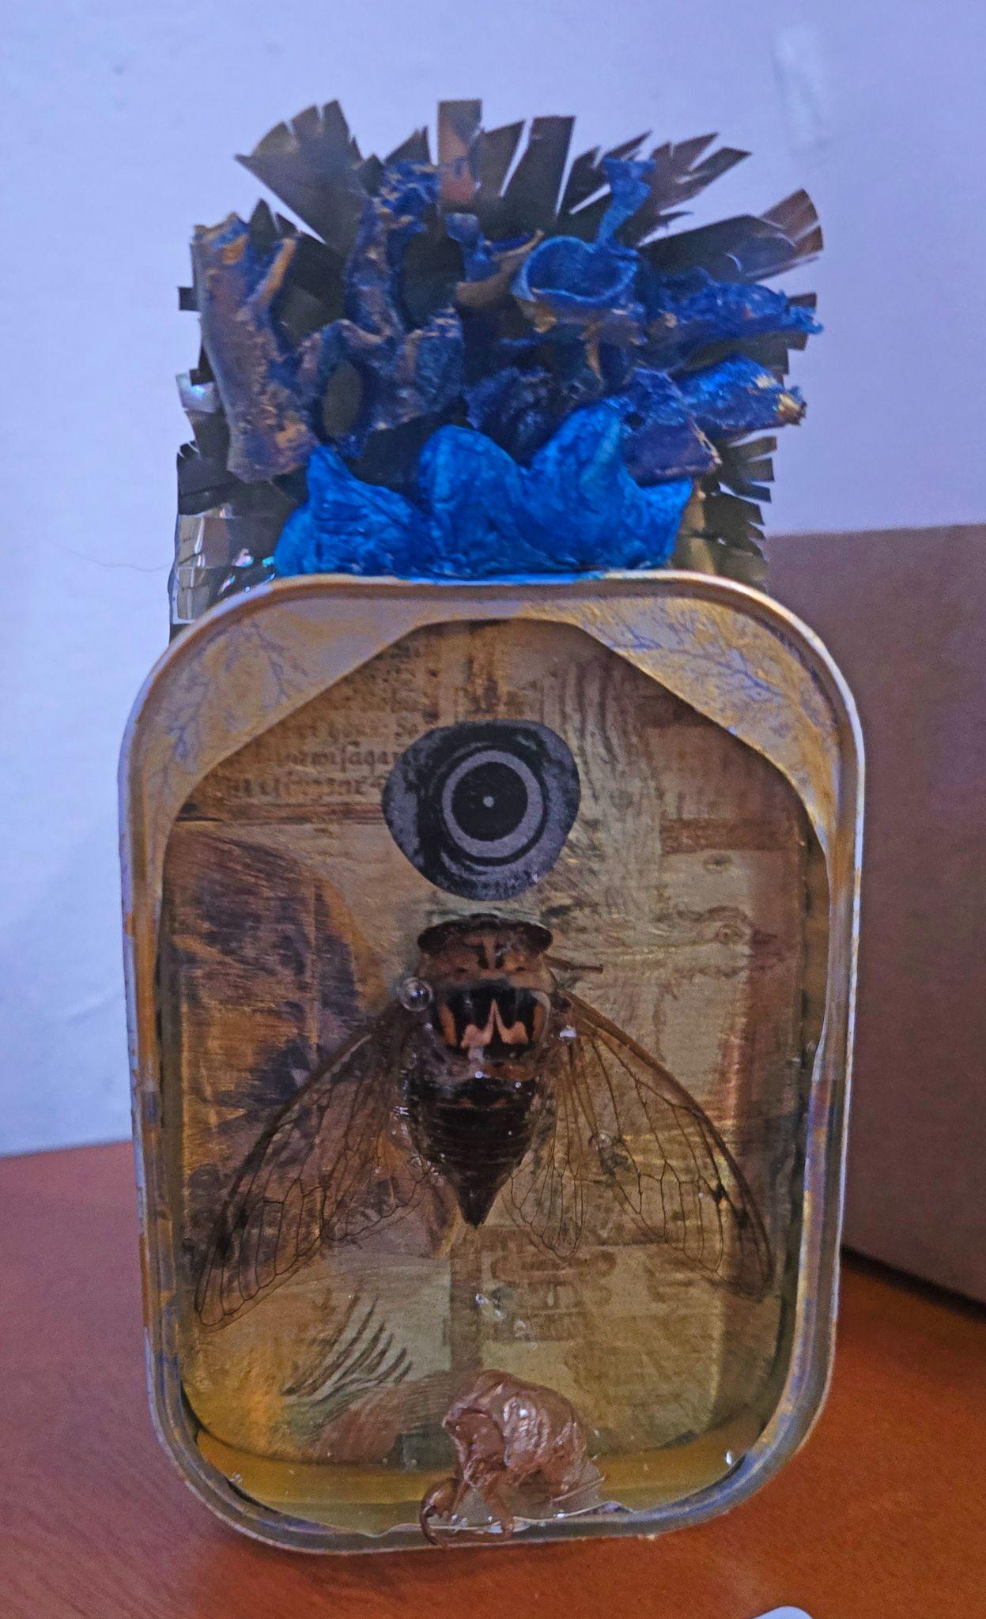

Juror’s Choice: Mecca Givens
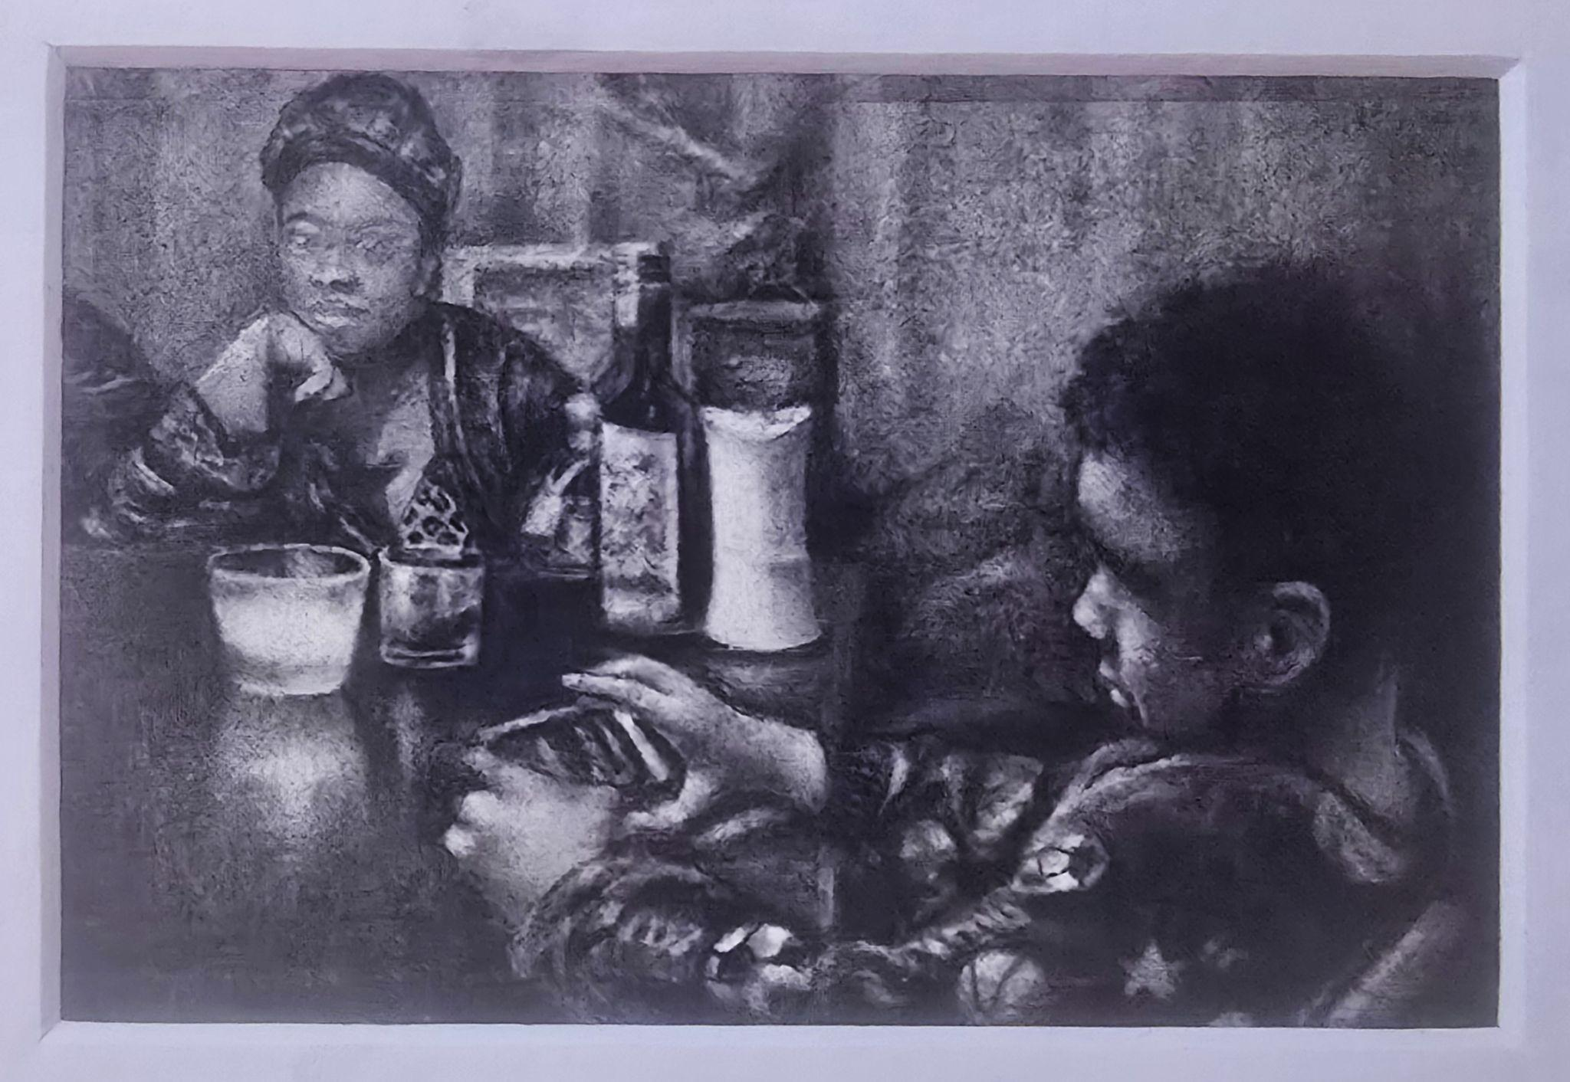

3 X 5 Member Exhibition Entry

Name: _______________________________________________________________________
Phone Number: _______________________________________________________________
Email: _______________________________________________________________________
Title: ________________________________________________________________________
Media: ______________________________________________________________________
Price: _______________________________________________________________________

You must pick up your work before you leave on Saturday, October 24.
We are not responsible for works left at the conference.

